Research Poster Project
Objective:
1. Work individually or in teams to develop research posters about a topic of your choice. Your topic MUST be approved by your teacher before you begin.
2. Research your topic. Find quality images and information for your topic. Complete the source tracking sheet as you go.
3. Complete the Poster Planning Sheet and Poster Outline then HAND IT IN FOR APPROVAL.
4. Once you have approval for your Planning Sheet, create a well designed informational poster that is free from errors.
5. Use Images and design to enhance the written informational content. Be sure that all images that you do not create yourself fall under Creative Commons licence.
6. Create a short survey to be completed BEFORE peers read your poster to gauge your audience’s background knowledge about your topic.
7. Create a short survey to be completed AFTER peers read your poster to gauge your audience’s knowledge about your topic after reading your poster.

Background Information:
PSAs (Public Service Announcements) are messages in the public interest which are shown in the media. The purpose is to raise awareness of an issue, influencing attitudes or actions for the good. See sample PSA posters included in this assignment. PSA posters include:

• A headline with a clearly stated positive message
• A dominant image or set of related images
• Important information about the topic
• Persuasive elements that grab the viewer’s attention
Your poster should follow these requirements:
• Colour scheme chosen for visual impact
• Attractive and easy to read
• Neat and free of spelling and grammatical errors
• Accurate information about your topic
• Include a chart or graph about your topic if appropriate

Don’t forget to make your surveys!
Sample PSA Posters: Professional and student examples that show the amount of information expected for each grade range.
C-/C/C+ level posters:
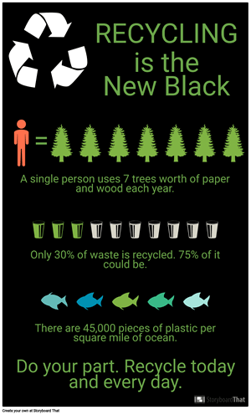
B level poster example:
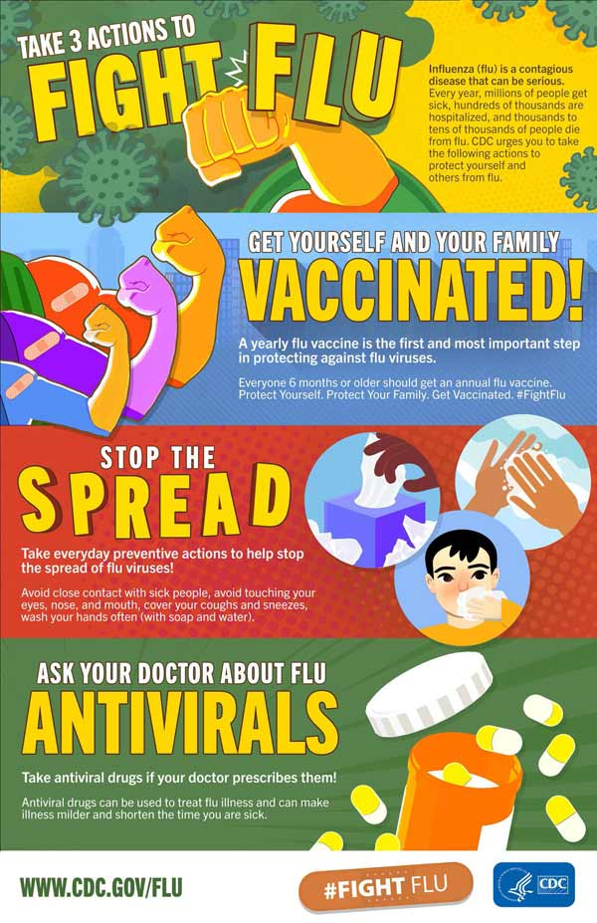
A level poster example:
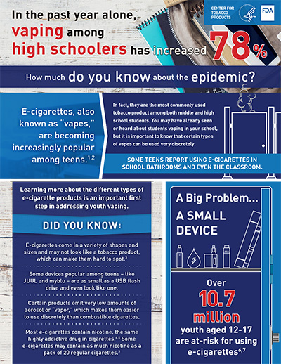
Source Tracking Sheet

Use this sheet to keep track of the resources you access for the project.

Book
Author(s):_____________________________________________________________
Title of Book:___________________________________________________________
Publishing City:_________________________________________________________
Publishing Company: ____________________________________________________
Copyright Date: _______________________ Page number(s) used: _______________

Online Encyclopedia (Grolier Multimedia, Canadian Encyclopedia, Etc.)
Author(s):_____________________________________________________________
Title of Section: ________________________________________________________
Title of Online Encyclopedia: ______________________________________________
Publishing Company: ____________________________________________________
Date of Publication: ______________________ Access Date: ____________________

Online Database
Author(s):_____________________________________________________________
Title of Article: _________________________________________________________
Title of Newspaper/Magazine/Journal: ______________________________________
Date of Publication: _____________________ Page #'s: _________________
Volume#: ___________ Date of Access: ____________________________
Name of Online Service: _________________________________________________
URL (record to end of domain [.com/.ca/]): ___________________________________

Internet Web Site
Author(s) (if available): ___________________________________________________
Title of Section of the Web Site: ____________________________________________
Title of the Whole Web Site: _______________________________________________
Date of Posting/ Updated/ Modified: _________________________________________
Access Date: ___________________________________________________________
URL (web address): ______________________________________________________

Internet Web Site
Author(s) (if available): ___________________________________________________
Title of Section of the Web Site: ____________________________________________
Title of the Whole Web Site: _______________________________________________
Date of Posting/ Updated/ Modified: _________________________________________
Access Date: ___________________________________________________________
URL (web address): ______________________________________________________

Internet Web Site
Author(s) (if available): ___________________________________________________
Title of Section of the Web Site: ____________________________________________
Title of the Whole Web Site: _______________________________________________
Date of Posting/ Updated/ Modified: _________________________________________
Access Date: ___________________________________________________________
URL (web address): ______________________________________________________
Internet Web Site
Author(s) (if available): ___________________________________________________
Title of Section of the Web Site: ____________________________________________
Title of the Whole Web Site: _______________________________________________
Date of Posting/ Updated/ Modified: _________________________________________
Access Date: ___________________________________________________________
URL (web address): ______________________________________________________

Internet Web Site
Author(s) (if available): ___________________________________________________
Title of Section of the Web Site: ____________________________________________
Title of the Whole Web Site: _______________________________________________
Date of Posting/ Updated/ Modified: _________________________________________
Access Date: ___________________________________________________________
URL (web address): ______________________________________________________

Internet Web Site
Author(s) (if available): ___________________________________________________
Title of Section of the Web Site: ____________________________________________
Title of the Whole Web Site: _______________________________________________
Date of Posting/ Updated/ Modified: _________________________________________
Access Date: ___________________________________________________________
URL (web address): ______________________________________________________
Poster Planning Sheet

1. Issue or Topic:________________________________________________________________

2. Your position (for persuasive/opinion):_____________________________________________

3. Find 8 pieces of evidence or supporting details:

4. Highlight your 3 strongest pieces of evidence or supporting details.

5. Write a poster title or catch phrase based on your topic, position, and evidence:

______________________________________________________________________________

______________________________________________________________________________

6. Complete the Poster Outline on the following page.

Poster Outline
Poster title or catch phrase__________________________________________________________

______________________________________________________________________________

Point 1
Topic/Point 1: _________________________________________________________________
______________________________________________________________________________
Supporting details or images
- ________________________________________________________________________
- ________________________________________________________________________
- ________________________________________________________________________
Point 2
Topic/Point 2: _________________________________________________________________
______________________________________________________________________________
Supporting details or images
- ________________________________________________________________________
- ________________________________________________________________________
- ________________________________________________________________________
Point 3
Topic/Point 3: _________________________________________________________________
______________________________________________________________________________
Supporting details or images
- ________________________________________________________________________
- ________________________________________________________________________
- ________________________________________________________________________

Page 1 of 2
Research Poster Project Rubric

Student:

Score | 3 - 4 | 2 - 3 | 1 - 2 | 0 - 1
Category | Exceeds Expectations | Meets Expectations | Approaching Expectations | Below Expectations
Purpose | The Purpose of the poster is clearly accomplished. | The purpose of the poster is mostly clear. | The purpose of the poster is somewhat clear. | The purpose of the poster is unclear.
Images | All images add to the message. | None of the images detract from the message. | Some images may detract from the message OR insufficient images. | The images are not well thought out, laid out, or are distracting.
Mechanics | There are no grammatical/mechanical mistakes on the poster. | There are few grammatical/mechanical mistakes on the poster. | There are some grammatical/mechanical mistakes on the poster. | There are multiple grammatical/mechanical mistakes on the poster.
Layout and design | Poster is of exceptional quality. Layout and design clearly communicate message in an appealing manner. | Poster is of high quality. Layout and design clearly communicate message in a somewhat appealing manner. | Layout and design are not well used to convey message and attract attention. | Layout and design are not well used. Poster is of poor quality, is confusing, or disorganized.
Creativity | The poster is highly original and creative. | The poster is somewhat original and creative. | The poster is somewhat original and creative. | The poster is not original and creative.
Messaging | Information and messaging are professional and clear. | Information and messaging are well thought out and clear. | Information and messaging are unprofessional but clear. | Information and messaging are unclear.
Initial Survey | Survey is professional, well thought out, and gathers relevant information. | Survey is well thought out and gathers relevant information. | Survey is somewhat well thought out and gathers some useful information. | Survey is not useful or not appropriate.
Final Survey | Survey is professional, well thought out, and gathers relevant information. | Survey is well thought out and gathers relevant information. | Survey is somewhat well thought out and gathers some useful information. | Survey is not useful or not appropriate.

Poster Score /32
Notes:

Page 2 of 2
Research Poster Project Rubric

Student:

Score | 6 - 8 | 4 - 6 | 2 - 4 | 0 - 2
Category | Exceeds Expectations | Meets Expectations | Approaching Expectations | Below Expectations
Research | Topic has been thoroughly researched using high-quality sources. | Topic has been well researched using quality sources. | Topic has been minimally researched or uses low-quality sources. | Topic has not been well researched or does not use quality sources.
Citations | Proper citations used for every source. | Proper citations used for almost every source. | Proper citations used for some sources or sources improperly cited. | Attempt was made to cite some sources.
Quality of information | Topic has been thoroughly explained using high-quality, relevant information. | Topic has been well explained using quality, relevant information sources. | Topic has been minimally explained or uses low-quality or irrelevant information. | Topic has not been well explained, includes irrelevant information, or does not use quality information.
Quantity of information | Topic has been thoroughly explained using just the right amount of relevant information. | Topic has been well explained using a reasonable amount of quality, relevant information sources. | Topic has been minimally explained or over-explained. | Amount of information is overwhelming or insufficient.

Research Score /32
Notes:

Some material adapted from http://dev.definingus.org/wp-content/uploads/2019/04/Current-Events-PSA-Poster.pdf

